Henderson Family Reunion

Location: 3721 S. Choctaw road
Date: May 27th @ 1:30 PM
Activities: Soccer, Kickball, & Volleyball
Food: Hamburgers, Hotdogs, and some good old fashion pie
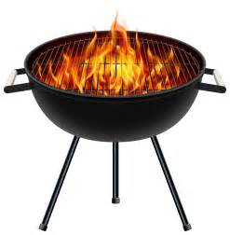
Come join the family for good food, people, and fun!

